**Road Lane Detection System**

*Submitted in the partial degree of the requirement*

*For the award of the degree of*

**Bachelor of Computer Application**

To

Guru Govind Singh Indraprastha University ,Delhi

Guide: Summited by:

Dr. Pankaj Varshney Harsh Kumar Mehta

(02713702020)

Harshita Ahuja

(02913702020)



**Institute of Information Technology & Management**

**New Delhi-110058**

**Batch(2020-2023)**

**Certificate**

**Harsh Kumar Mehta(02713702020) and Harshita Ahuja(02913702020)** certify that the Sumer Training Project Report (BCA-355) entitled **“Road Lane Detection System”** is done by us and it is authentic work carried out by us at  **Institute of Information Technology & Management**

The Matter embodied in this project work has not been submitted earlier for the award of any degree or diploma to the best of my knowledge and belief

Date:

Certified that the Project Report(BCA-355) entitled **“Road Lane Detection System”**

done by the above student is completed under my guidance.

**Chapter 1-:Software Project Planning**

* 1. **Description of the Software System under Study**

The traffic safety becomes more and more convincing with the increasing urban traffic. Exiting the lane without following proper rules is the root cause of most of the accidents on the avenues. Most of these are result of the interrupted and lethargic attitude of the driver. Lane discipline is crucial to road safety for drivers and pedestrians alike. The system has an objective to identify the lane marks. Its intent is to obtain secure environment and improved traffic surroundings. The functions of the proposed system can range from displaying road line positions to the driving person on any exterior display, to more convoluted applications like detecting switching of the lanes in the near future so that one can prevent concussions caused on the highways.

Actuate detection of lane roads is a critical issue in lane detection and departure warning systems. If an automobile crosses a lane confinement, then vehicles enabled with predicting lane borders system directs the vehicles to prevent collisions and generates an alarming condition. These kind of intelligent system always makes the safe travel but it is not always necessary that lane boundaries are clearly noticeable, as poor road conditions, inadequate quantity of paint used for marking the lane boundaries makes it hard for system to detect the lanes with accuracy and other reasons can include environmental effects like shadows from things like trees or other automobiles, or street lights, day and night time conditions, or fog occurs because of invariant lightening conditions. These factors cause problem to distinguish a road lane in the backdrop of a captured image for a person.

In order to deal with above stated problems arising due to changes in lane boundaries. The algorithm followed in this paper is to detect lane markings on the road by giving the video of the road as an input to the system by using computer vision technology and primarily designed with the objective of reducing the frequency of accidents. System can be installed in cars and taxis in order to prevent the occurrence of accidents due to reckless driving on the roads. In school buses as it will guarantee the safety of the children. Moreover, performance of the driver can also be monitored, Road Transportation Offices can use the setup to check and report the negligence of drivers and lack of attention on the roads.

* 1. **Tools/Platform** 
     1. **Hardware Specification**
* Hard Disk: - 500 GB
* Processor: INTEL CORE i5
* RAM: - 4 GB
* Front end: - Kivy, Python, Machine Learning ,Open CV(Computer Vision)
  + 1. **Software Specification**
* Operating System: - Android version Lollipop (5.1) or above, IOS 12.3 Or above.
* Android Development Toolkit (ADT)
  1. **Project Planning-:**
  2. **Methodology-:**
     1. **SDLC Model-:**

We are going to use the **Waterfall model** for our project because of many facilities.

* **Planning and requirement:** All possible requirements of the system to be developed are captured in this phase and documented in a requirement specification document.
* **Analysis and design:** The requirement specifications from first phase are studied in this phase and system design is prepared. It helps in specifying hardware and system requirements and also helps in defining overall system architecture.
* **Implementation:** With inputs from system design, the system is first developed in small programs called units, which are integrated in the next phase. Each unit is developed and tested for its functionality which is referred to as Unit Testing.
* **Testing:** All the units developed in the implementation phase are integrated into a system after testing of each unit. Post integration the entire system is tested for any faults and failures.
* **Evaluation:** This will evaluate the outcome of the processing whether the application is running successfully or not.

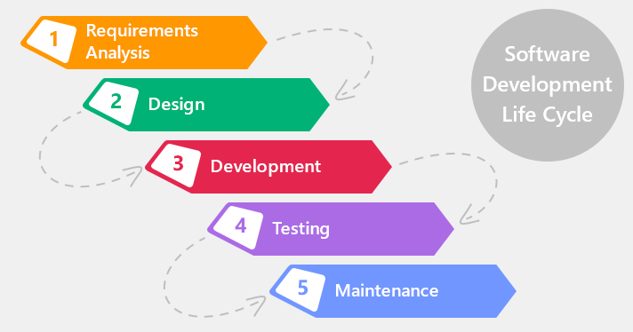

* + 1. **Justification For the selection of model-:**
* It is very simple to understand and use.
* As we are new to this it is very difficult to analyses all requirements at once. Building the whole application at once is not possible for us.
* So, by dividing the Project into small parts and implementing them makes easy for us to make this application.